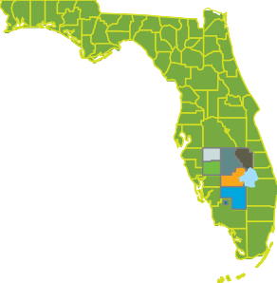

FFLORIDA HHEARTLAND ECEONOMIC RREGION OF OPOPORTUNITY DESOTO • GLADES • HARDEE • HENDRY • HIGHLANDS • OKEECHOBEE BELLE GLADE • IMMOKALEE • PAHOKEE • SOUTH BAY

FHERO BOARD OF DIRECTORS MEETING AGENDA
March 23, 2023

- Roll Call/Introductions
- Financial Review and Approval
- Old Business – None
  - 2022-2023 RDG Submittal Discussion
  - Rural Days in Tallahassee
- New Business
  - Broadband Implementation
    - LTPT
  - USDA Rural Program Presentation
  - Legislative issues
- Adjournment

